**CSC263 Database Systems**

**Final Examination - Hands-on (Max Points: 55 pts)**

NAME: ______Steven Moody___________ SCORE: __________________/55

Problem 1. Create a “**ECom**” database by using the script provided.

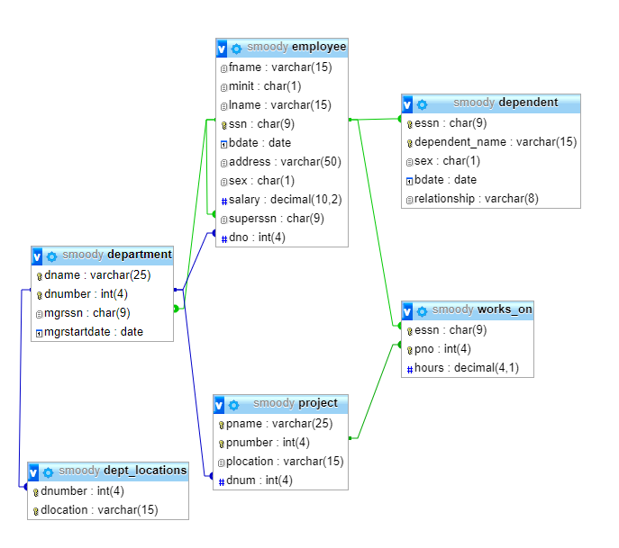

Problem 2. Depict the schema of the database.

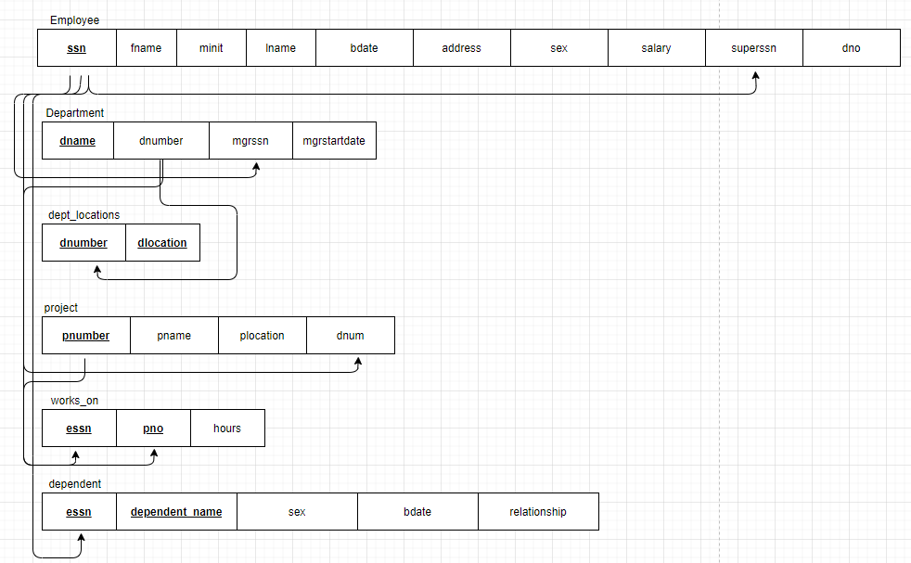

Problem 3. Write and execute queries to accomplish the following tasks. Show SQL queries you used and show screenshots of the query execution results. You must write queries that follow the specified headings to display the results.

**1. Determine how many Customers in database have an email.**

|  |
| --- |
| Total Number of Customers who have emails |

**2. Determine highest, lowest, and average price of all products.**

|  |  |  |
| --- | --- | --- |
| Highest Price | Lowest Price | Average Price |

**3. In descending of number of products supplies, list vender names and the total number of products EACH vendor supplies.**

|  |  |
| --- | --- |
| Vendor Name | Number of products supplies |

1. **In descending order of the number of orders, list customer name, the state customer is in, aned the total number of orders placed by each customer.**

|  |  |  |
| --- | --- | --- |
| Customer Name | State | Total Number of Orders |

1. **For order numbered 20007, in alphabetic order of the venter name, list all ordered items information, including vendor name, product name, product unit price and quantity.**

|  |  |  |  |
| --- | --- | --- | --- |
| Vendor Name | Product Name | Product Unit Price | Quantity |

1. **List all orders and the total number of items contains in each order**

|  |  |
| --- | --- |
| Order Number | Number of Items in order |

1. **List all the products that have something to do with “teddy bear”.**

|  |
| --- |
| Name of the products that related to “teddy bear” |

1. **(You must involve the keyword JOIN in this query.) Write a query to retrieve the following information.**

|  |  |  |  |
| --- | --- | --- | --- |
| Order Number | Customer Name | Customer Contact | Email |

1. **For each customer, find all the vendors who are in the same state as the customer is in.**

|  |  |  |  |
| --- | --- | --- | --- |
| Customer Name | Vender Name | Customer State | Vendor State |

1. **For each customer, find all the vendors who are in the same state as the customer is in. (including vendors that do not have a known state)**

|  |  |  |  |
| --- | --- | --- | --- |
| Customer Name | Vender Name | Customer State | Vendor State |

1. **(a) Create a view called “CustomerOrder” that contains customer name, all the orders by each customer, all the item names contained in each order, as well as the price for each item. (b) Query the view to retrieve the following information.**

|  |  |  |
| --- | --- | --- |
| Customer Name | Order Name | Number of Iterms in the order |

**Bonus Question (10 pts)**

**Create a trigger and demonstrate the usage of it with queries**